**Desktop Assistant using AI - Ellie**

**Objective-** To design a desktop assistant using Natural Language Processing (NLP) with Python v3.9.2.

**Technologies Used-**

Virtual assistants use [natural language processing](https://en.wikipedia.org/wiki/Natural_language_processing) (NLP) to match user text or voice input to executable commands.

* [Speech recognition](https://en.wikipedia.org/wiki/Speech_recognition)
* [Natural language understanding](https://en.wikipedia.org/wiki/Natural_language_understanding),
* [Natural-language generation](https://en.wikipedia.org/wiki/Natural-language_generation).

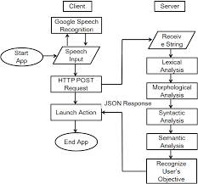

**Applications-**

* Health Status Monitor
* Maintaining the To – Do List, Calendar etc.
* Task Scheduling
* In Personal Finance

*Fig – Flowchart*

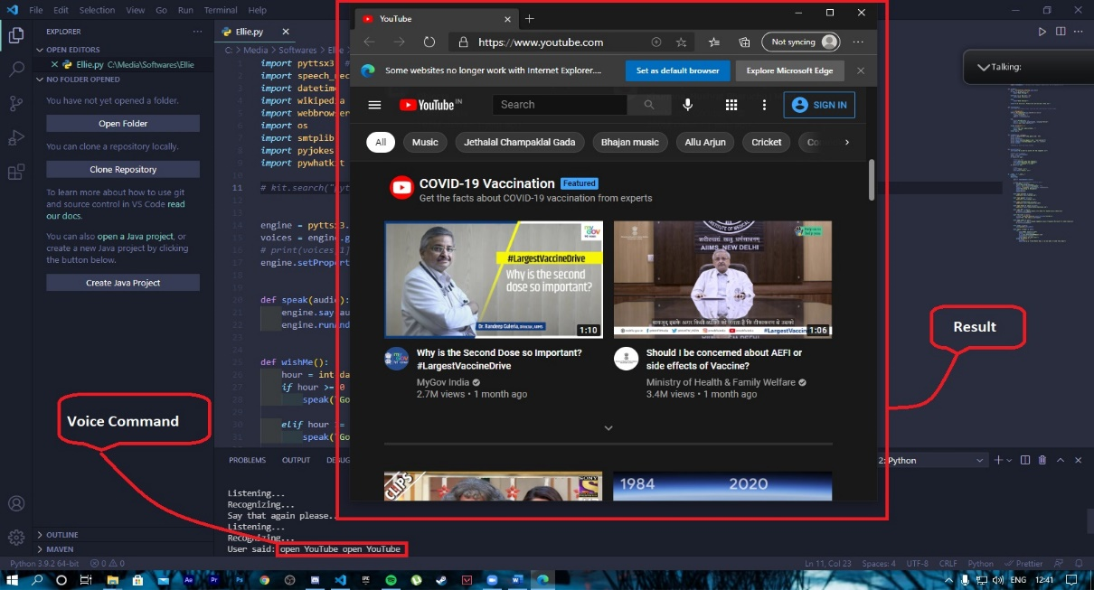

*Fig - Opening YouTube in browser*

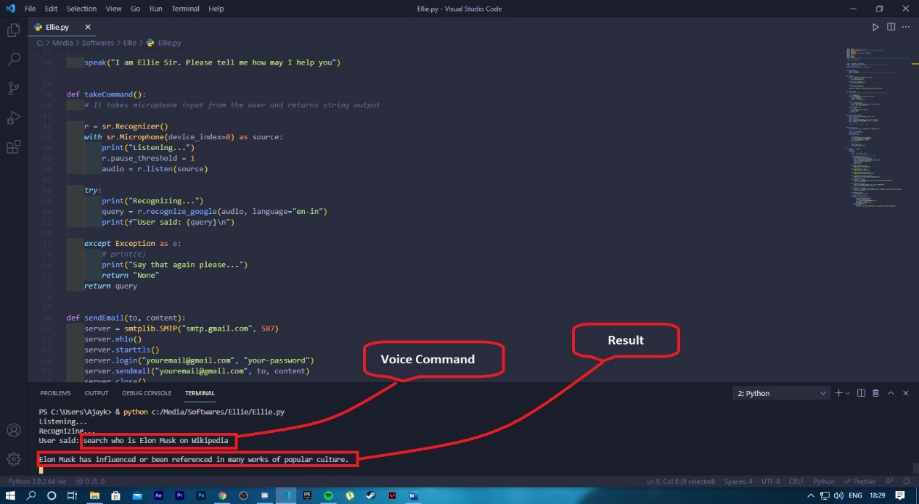

**Made by –**

Ajay Kumar

Akash Rai

B. Tech, 3rd Year

CSE Department

*Fig – Searching on Wikipedia*